9. Inversion of Control (IoC) & Dependency Injection (DI)

Inverted / Inversion of Control (IoC)
With IoC, the framework (Spring) controls:
- Object creation
- Object lifecycle
- Dependency injection

Example (With IoC)
@Component
public class Car {
@Autowired
Engine engine; // Spring provides the object
}

Example (Without IoC)
public class Car
{
Engine engine = new Engine(); // developer controls object creation
}

Why the Word “Inverse”?
Aspect | Traditional | IoC
Object creation | Developer | Spring
Dependency management | Developer | Spring
Control | Application code | Framework
NOTE: Control is inverted from application → framework

NOTE: IoC is implemented using Dependency Injection in Spring.

Dependency Injection (DI)
Dependency Injection is a design pattern where an object’s dependencies are provided externally rather than created internally.
Don’t create objects inside a class → Inject them from outside

Without DI:
- Classes become tightly coupled
- Code is hard to test
- Changes in one class affect many others
With DI:
- Loose coupling
- Easy testing
- Better maintainability

Types of Dependency Injection (3 Types)

1️. Constructor Injection (Most Recommended)
class Car {
private Engine engine;

public Car(Engine engine) {
this.engine = engine;
}
}
✔ Best practice
✔ Ensures dependency is always available

Setter Injection
class Car {
private Engine engine;

public void setEngine(Engine engine) {
this.engine = engine;
}
}
✔ Optional dependency
❌ Dependency may be missing

Field Injection (Not Recommended)
class Car {
@Autowired
private Engine engine;
}
❌ Hard to test
❌ Hidden dependencies

DI vs IoC (Very Important)
DI | IoC
Technique | Principle
Injects dependencies | Controls object creation
Part of IoC | Broader concept

DI in Spring Framework
Spring container creates and injects objects automatically.

Example
@Component
class Engine {
}
@Component
class Car {
private Engine engine;
@Autowired
public Car(Engine engine) {
this.engine = engine; }
}

@Component is used
- To mark a Java class as a Spring-managed bean.
- Automatically creates object (bean)
- Enables Dependency Injection
- Avoids XML configuration

Special types of @Component
Annotation | Used For
@Component | Generic class
@Service | Service layer
@Repository | DAO layer
@Controller | MVC Controller

@Autowired — Purpose in Spring
@Autowired is used to automatically inject one Spring bean into another bean.
It connects one object with another object automatically.
- Avoids new keyword
- Enables Dependency Injection
- Reduces boilerplate code
- Supports loose coupling
By default, Spring injects dependency by type.
- If multiple beans of same type exist:
@Autowired
@Qualifier("dieselEngine")
private Engine engine;

10. Implementing DI & IoC with Primitive and Non-Primitive Types

Primitive Types
- int
- long
- float
- double
- boolean
- char
- String

Non-Primitive Types
- Custom class object (Course)
- Collection (List<String>)

Create Spring Boot Project

Create Spring Boot Project (Step-by-Step)

✅ Step 1: Go to Spring Initializr
👉 https://start.spring.io

✅ Step 2: Fill Project Details
Field | Value
Project | Maven
Language | Java
Spring Boot | Default
Group | com.klu
Artifact | di-ioc-demo
Name | di-ioc-demo
Packaging | Jar
Java | 17 or 21
Dependency | Spring web

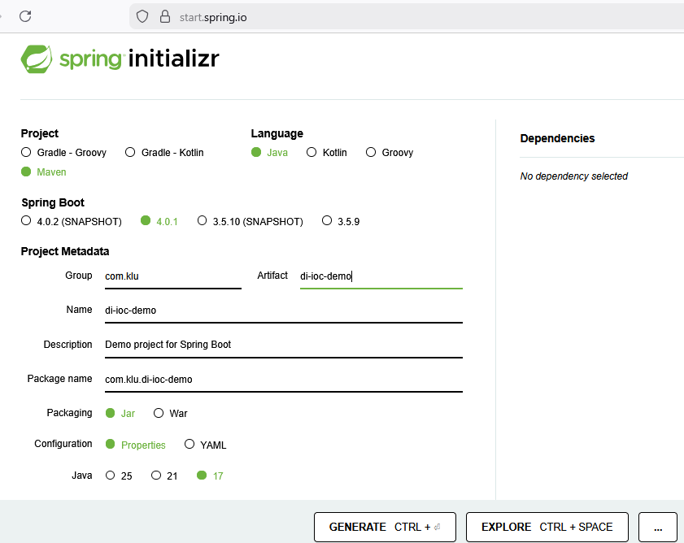

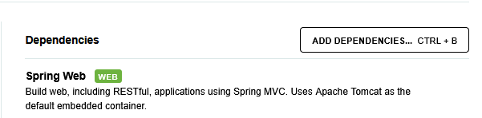

Click on “Generate” Button.

ZIP file will be downloaded. Unzip it first.

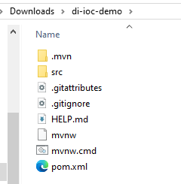

Open this project in Spring.

Import the Project into Spring

Steps in Spring:
- File → Import…
- Choose Existing Maven Projects
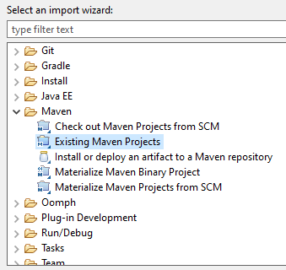
• Click Next --> Click Browse Navigate to your extracted folder
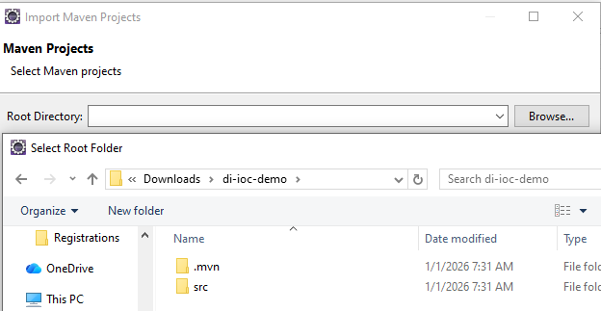
Click Next Button
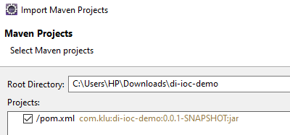
Ensure pom.xml is checked in “Projects” box
Click Finish
➡ Spring will import the project.

Wait for Dependencies to Download
Eclipse will automatically download:
✔ Spring Boot starter dependencies
✔ Maven plugins
✔ Build tools
Wait until the progress bar finishes.
Project Structure
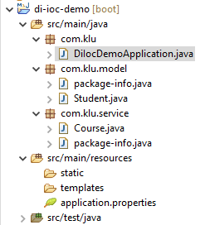

Non-Primitive Dependency Class

Course.java
package com.example.diiocalltypes.service;

import org.springframework.stereotype.Component;

@Component
public class Course {

public String getCourseName() {
return "Spring Boot & DI";
}
}
✔ Non-primitive object
✔ Created by IoC container

Student Class (ALL Primitive + Non-Primitive DI)

Student.java

package com.example.diiocalltypes.model;

import java.util.List;

import org.springframework.beans.factory.annotation.Autowired;

import org.springframework.beans.factory.annotation.Value;

import org.springframework.stereotype.Component;

import com.example.diiocalltypes.service.Course;

@Component

public class Student {

// ===== Primitive Type Dependencies =====

@Value("101")

private int id;

@Value("9876543210")

private long phone;

@Value("85.5")

private float marks;

@Value("72.45")

private double percentage;

@Value("true")

private boolean active;

@Value("A")

private char grade;

@Value("Rama")

private String name;

// ===== Collection Dependency =====

@Value("#{'Maths,Physics,Computers'.split(',')}")

private List<String> subjects;

// ===== Non-Primitive Object Dependency =====

@Autowired

private Course course;

public void display() {

System.out.println("---- Student Details ----");

System.out.println("ID : " + id);

System.out.println("Name : " + name);

System.out.println("Phone : " + phone);

System.out.println("Marks : " + marks);

System.out.println("Percentage : " + percentage);

System.out.println("Active : " + active);

System.out.println("Grade : " + grade);

System.out.println("Subjects : " + subjects);

System.out.println("Course : " + course.getCourseName());

}

}
-----------------------------------------------------------------

Main Class (IoC + Run Logic)

DiIocDemoApplication.java
------------------------------------------------------------------
package com.klu;

import org.springframework.boot.CommandLineRunner;
import org.springframework.boot.SpringApplication;
import org.springframework.boot.autoconfigure.SpringBootApplication;
import org.springframework.context.ApplicationContext;

import com.klu.model.Student;

@SpringBootApplication
public class DiIocDemoApplication implements CommandLineRunner {

private final ApplicationContext context;

public DiIocDemoApplication(ApplicationContext context) {
this.context = context;
}

public static void main(String[] args) {
SpringApplication.run(DiIocDemoApplication.class, args);
}

@Override
public void run(String[] args) {
Student student = context.getBean(Student.class);
student.display();
}
}

Run the Project
- Right click project → Run As → Spring Boot App

- 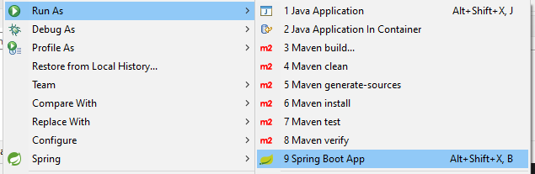
If you get error: Web server failed to start. Port 8080 was already in use.
Do as follows: and again run the application.
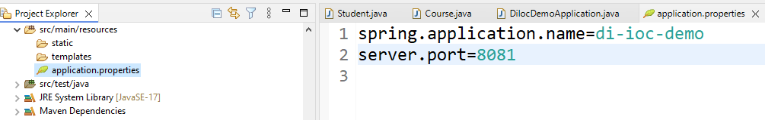
OUTPUT
---- Student Details ----
ID : 101
Name : Rama
Phone : 9876543210
Marks : 85.5
Percentage : 72.45
Active : true
Grade : A
Subjects : [Maths, Physics, Computers]
Course : Spring Boot & DI

With CommandLineRunner

@SpringBootApplication
public class DemoApplication implements CommandLineRunner {

@Autowired
private Student student;

@Override
public void run(String... args) {
student.display();
}
}
✔ Beans created
✔ Dependencies injected
✔ Your logic executed automatically

